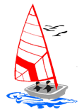

Staunton Harold Sailability Trust Water Sports for People with Disabilities
These sessions are aimed at anyone with any additional support need. You don’t need to be registered as disabled or have a diagnosed condition to attend.
We aim to extend the opportunities we can offer to a greater number of people in Derbyshire, Leicestershire and the surrounds, but we still keep the same ethos of challenging people and their perception of themselves through new activities that they will not have experienced and that offers a level playing field for all.
We offer on land activities, supported or independent sailing , sensory experiences through sail or powerboat, more details can be found on our website.
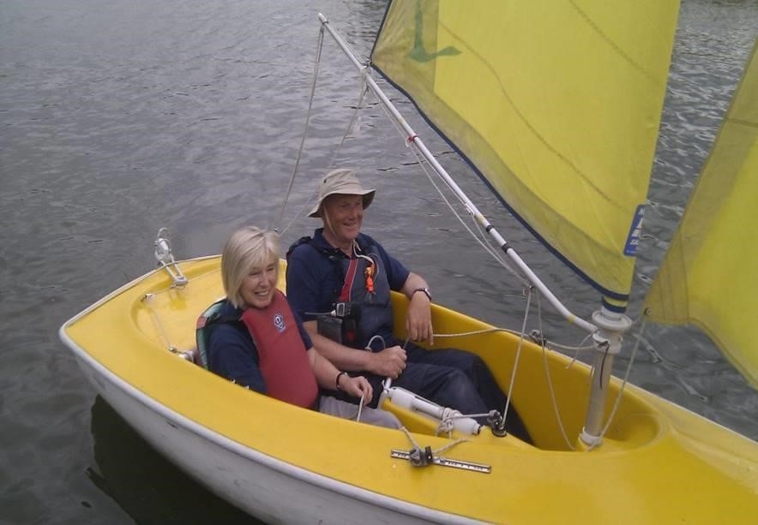
We work to enable disabled people, and those with any additional support needs, of all ages to participate in water sports. We are a registered Charity based at an RYA Sailability Centre as part of the Staunton Harold Sailing club. To ensure that we meet the exacting standards of the Royal Yachting Association, The club are inspected annually.
Our vision is to have more integrated water sports, whereby people with an impairment are supported in a mainstream environment. However, we recognise that this is not always possible or desirable, so we aim to provide sessions which meet all needs and tastes.
Participants may have physical, mental emotional or perception difficulties, but all are encouraged to take part in water based activity. It is often the first time that they are able to feel free from a debilitating condition and to be involved in such a challenging activity.
“Our students gain so much in coming to SHST!”
“It is a fantastic opportunity for our students to experience new things and develop skills in a safe, fun and supported environment”
“There’s something for everyone – all are included and have fun”
If you would like to discuss bringing your school, an individual or group down to participate with us, please contact through our website, www.shst.org.uk We look forward to hearing from you.

Staunton Harold Sailability Trust

